Running head: MISSION BIOTECH: A CATS-BASED EVALUATION

Team 2
Ghania Zgheib
David Vallett
Michelle Dunham
Analysis Paper for the Fulfillment of Project Requirement for
EDIT 802, Fall 2011

Instructor: Dr. Nada Dabbagh
George Mason University

Mission Biotech: A CATS-Based Analysis

Interaction in a technology supported learning environment (TSLE) may seem different from face to face environments where the teacher and peers are physically present. Therefore, the affordances of a TSLE are extremely important so that learning happens. An affordance is a term coined by Gibson to refer to the characteristics of an object that stimulate the actions of an actor in a certain environment.
Affordances and abilities (or effectivities or aptitudes) are, in this view, inherently relational. An affordance relates attributes of something in the environment to an interactive activity by an agent who has some ability, and an ability relates attributes of an agent to an interactive activity with something in the environment
that has some affordance (Greeno, 1994, p. 338).

Gibson’s description of affordances suggests that the tool with which an individual interacts is animate as well, and there is a mutual interaction between the actor and the environment. Gaver (1991) adapted Gibson’s definition of affordances to the design and evaluation of user interfaces in human machine interaction. As a result, he classified affordances into three types: perceived, hidden, and false affordances. Perceptual affordances in interface design are perceivable characteristics or abilities of the tool to the learner so that action can take place immediately. Hidden affordances are more complex abilities of a tool that cannot be perceived without a cognitive activity (Albrechtsen et al. 2001). As for false affordances, they represent misinforming abilities of a tool. Therefore, a designer must pay careful information to the design of an interface so that the learner will not be misinformed about some of its characteristics.

Based on Gibson’s description of affordances, a Cognitive Affordances Technologies Scale (CATS) was developed based on the literature in Fall 2010 by Dr. Dabbagh and two doctoral students in EDIT 802 to support user-centered design features in a technology supported learning environment. Initially the scale had seven categories of cognitive affordances: (1) experiential learning, (2) dialogic learning, (3) supportive learning, (4) learning by doing, (5) critical thinking, (6) conceptual change, and (7) self-regulated learning. Each category had several sub-categories that described features of the main categories.
In Fall 2011, a group of eight doctoral students in EDIT 802 revised the scale based on the course readings and class discussions. As a result, the seven main categories were reduced to 3 main categories with two main sub-categories each, and sub-categories for the two main subcategories resulting in a three-level scale. The new categories were: (1) situated learning, (2) supportive learning, and (3) knowledge building. Table 1 summarizes the new scale layout.

Table 1. CATS revised- Fall 2011

Situated Learning
Experiential Learning
- Inquiry-Based
- Hypothesis Generation
- Experimentation
- Exploration
Active Learning
- Personally Relevant
- Authentic
- Context Based
- Build Artifacts
- Role Playing
Supportive Learning
Self-Regulated
- Time Management
- Self-Evaluation
- Goal Setting
- Task Strategies
Systems Support
- Multiple Representations
- Task Breakdown
- Feedback
- Scaffolding
Knowledge Building
Conceptual Change
- Action Reflection
- Problem Solving
- Decision Making
- Idea Generation
- Transfer
Dialogic Learning
- Collaboration
- Multiple Perspectives
- Sharing Knowledge
- Argumentation
- Articulation

The purpose of this scale is to evaluate TSLEs to determine whether they have cognitive affordances that support learning. Each team in the EDIT 802 had to select a TSLE to evaluate it based on the CATS scale. This paper presents a detailed analysis of an immersive technology supported game designed to teach learners how to use biotechnology skills.

Description of the TSLE
Mission Biotech is an immersive Serious Educational Game (SEG) designed to teach biotechnology skills by infusing the learner into the role of an epidemiology researcher at the National Laboratory for Biotechnology and Bioinformatics, created by researchers in science education, computer science, and microbiology from several universities in the United States. As an SEG, the TSLE is an electronic or computer-access game intended to target K-20 content knowledge (Annetta, 2010). Players in the game are tasked with diagnosing a deadly virus before it spreads through a city, and afforded the opportunities to explore resources that will aid them in successfully completing this mission (University of Florida Gainesville). The virtual world is created using 3-dimensional graphics, an interactive interface, and characters that help simulate the role of a biotechnology researcher, coupled with mini-games that teach and assess the learner's ability to employ biotechnology skills such as DNA isolation, Polymerase Chain Reaction (PCR), and gel electrophoresis. A link on the website allows instructors to gain access to dedicated curriculum materials for the environment, and presumably gain access to user data for assessment purposes as well.
The primary purpose of the game is served through immersion in a problem-based environment, wherein the learner identifies and tracks the spread of a mutant strain of virus that has the potential to become pandemic. The game opens with an in depth tutorial of the controls and functionality, which must be completed prior to moving into the content sections of the environment. A security guard/secretary serves to orient the user by asking them to click to view posters, highlight objects in order to interact with them, and create an identification badge using an in game computer that also serves as an introduction to the tool tray at the bottom of the user interface. After this introduction, the player is introduced to the director of the laboratory, who also presents the player with information regarding resources (posters on the walls) and the use of the journal/lab book, which is an ever available aid in the tool tray at the bottom of the user interface. Upon completion of the journal activity, a tab appears at the right of the interface that serves as a quick link to that section of the lab book, and the director instructs the user as to the nature of the problem to be solved (a deadly virus has been spreading throughout the city, and needs to be identified).
In order to solve the problem, the player takes part in mini-games or simulations that require specific knowledge of biotechnology skills. Each skill, in turn, is demonstrated using a voice and video tutorial, coupled with text. The learner is then asked to complete a journal or lab book outlining the steps in the tutorial, which can in turn be used as a guide whilst completing the mini-games. Thus the tasks are scaffolded, with active assistance being present but once, and passive assistance being present if the user chooses to seek it out, after working through an activity intended to improve retention. Feedback is provided by characters within the game, and more immediate feedback is provided by the game itself. For example, if a player performs a step incorrectly, the task fails, and the avatar is transported to an area of the lab where they can acquire new material to restart. Certain objects, necessary for the completion of the mini-game, are not accessible until the player has completed the tasks needed to use them successfully.

Technology Description

Mission Biotech is a three-dimensional virtual environment. The rendering of the environment is intended to provide the learner an authentic, first person experience (Figure 1). The technology provides interactive characters, authentic images and scenes, and full sound effects (sounds of footsteps when the character is walking down the hallway, door handles turning, doors opening, papers shuffling etc.). The site's authentic look, player movement, and sounds represent a clear effort to provide the learner with an immersive experience.

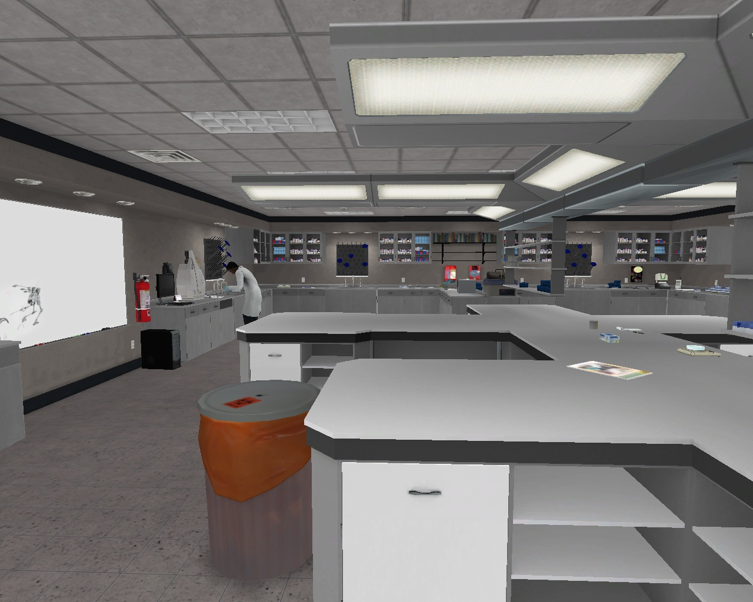
Figure 1. Mission Biotech Virtual Lab

There are two ways for the learner to play Mission Biotech. Once the learner downloads the software to a local computer, they might either play it locally or on-line. All learners (users) are required to create a login with a user name and password. If the user wants to play on-line they must create a user profile and submit it to the website for account creation; learners that choose to 'play locally' may immediately begin playing the game. Following account creation, the learner may then begin a new game with the selection of an avatar or continue a previously saved game. The options are identical for a user that elects to play online, save that user data is downloaded in real time to a database that tracks all user actions. Users that are continuing a saved game choose from a list displaying avatars and game progress for each game saved under that player's account.

For the start of a new game the learner must enter the lobby of Mission Biotech and meet Maria at the security desk (Figure 2). Maria provides initial instructions, introduces the game interface for movement, interaction and information and the creation of the learner’s avatar. The movement within the game is based on both using the mouse to provide a 360-degree visual field and orientation. The keyboard provides the learner movement to the right, left, forward and backwards (Figure 4). Users that are continuing a saved game choose from a list displaying avatars and game progress for each game saved under that player's account.

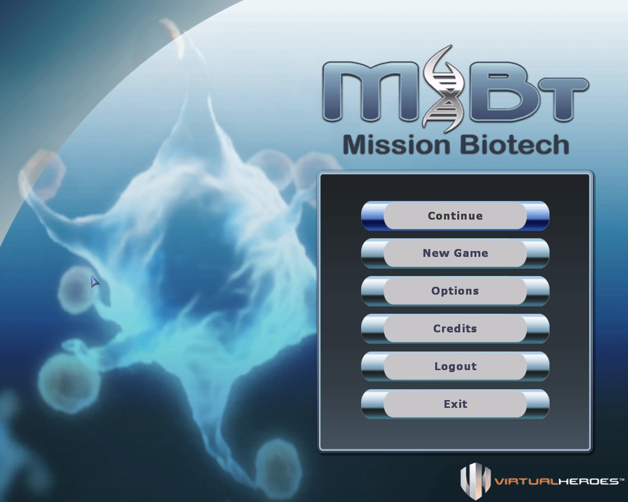 | 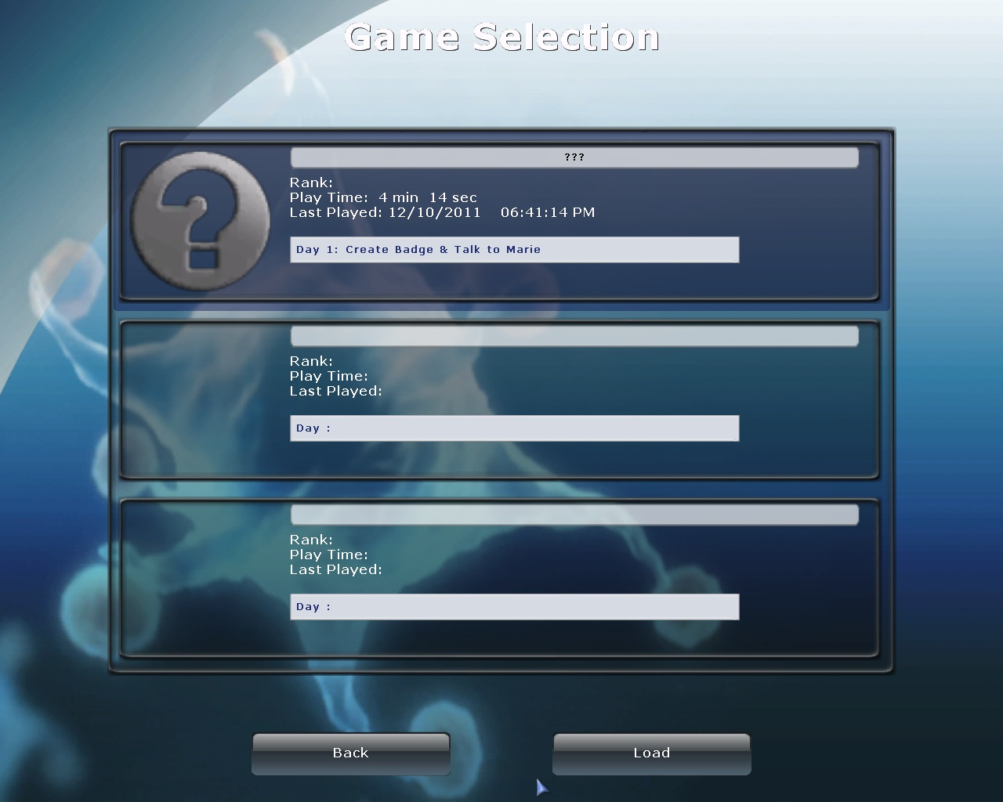

Figure 2. Initial learner interfaces

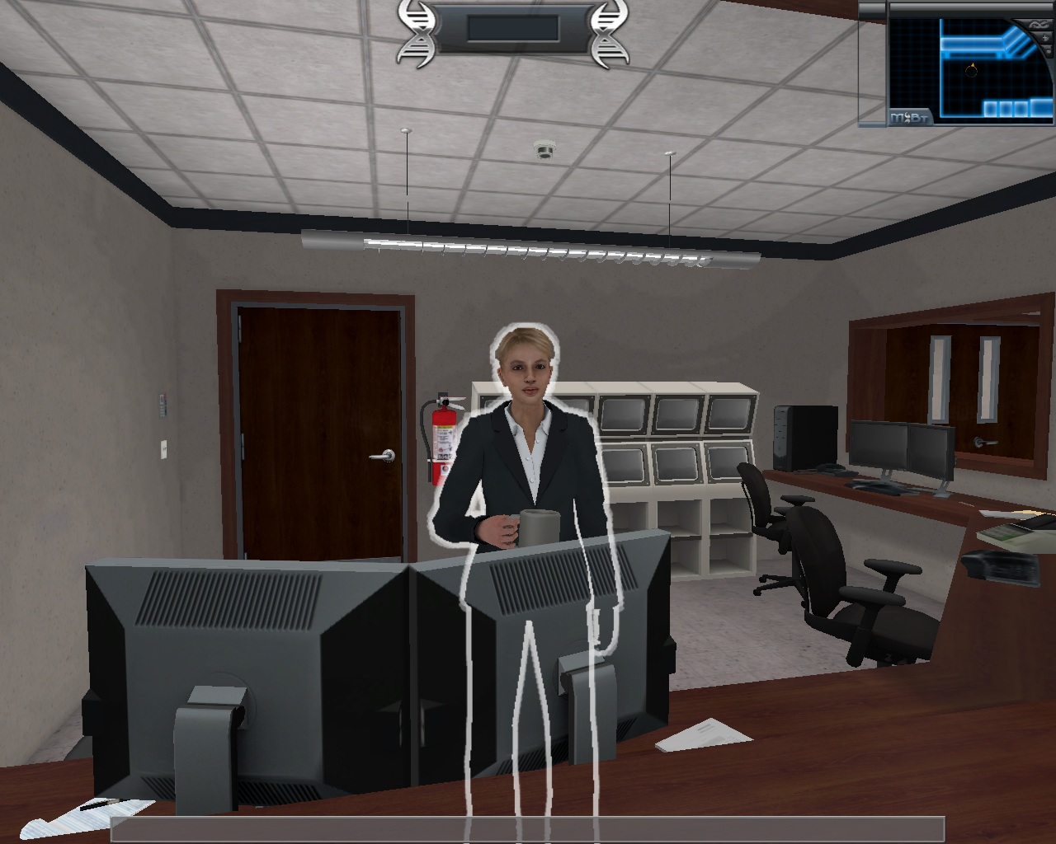 | 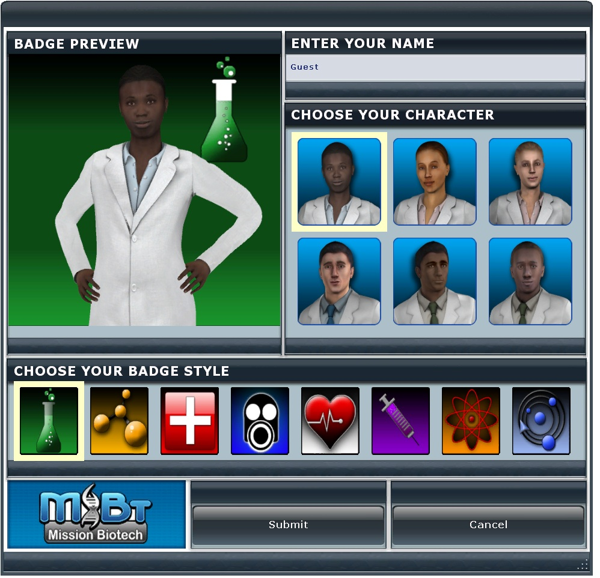
Figure 3. Entering the game and creating a character (avatar)
When the learner enters the lobby under a new game, they are required to create an avatar badge. The learner will select one of six images, select a background for the badge, and type in their name (Figure 3). The badge serves as the ‘score card’ for the learner, as it tracks their rank and achievements earned.

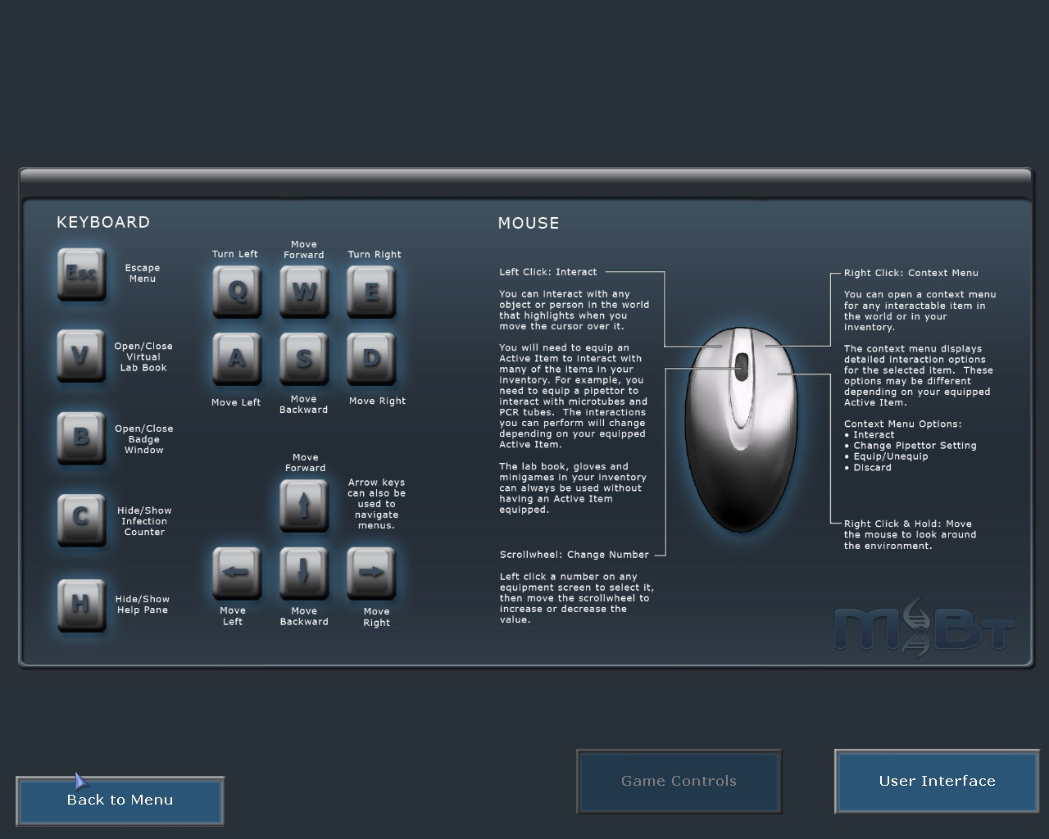
Figure 4. Learner interactive controls

The mini-map in the upper right corner of the screen (Figure 5) provides both information and clues for the learner. The mini-map shows a map of the building and where the learner is located in the building. Additionally it has an indicator to show the learner where important objects are in the room and a color display to let them know when they are getting close to an important object or clue.
The double rowed tray at the bottom of the screen is the user's inventory; any items the user picks up, selects, or creates will appear in one of the slots in this tray. In the middle of the slots is the active item indicator, as illustrated by the circular icon at the bottom of figure 5). The learner may drag inventory items into the circle to activate those items. Active items can then be combined with other collected items, or used on another item. At the lower middle of the tray is the sterile gloves status indicator. This indicates when the learner is not wearing gloves or when the learner gloves have become soiled or contaminated. The text box is in the upper center of the screen (Figure 5) and provides the learner information on their active item’s identity, function, and condition (e.g. “test tube: dirty” “spin collar: empty"). The infection counter is on the left side of the screen (Figure 5) and provides the learner with a sense of urgency and understanding of the rapid rate of infection over time. The infection counter also serves as the timer of the game. The longer the learner takes to complete the experiment the more people are infected. Workstations (Figure 6) are authentic and properly equipped. The game applies accurate measurements, functions, operation, outcomes and safety protocols.

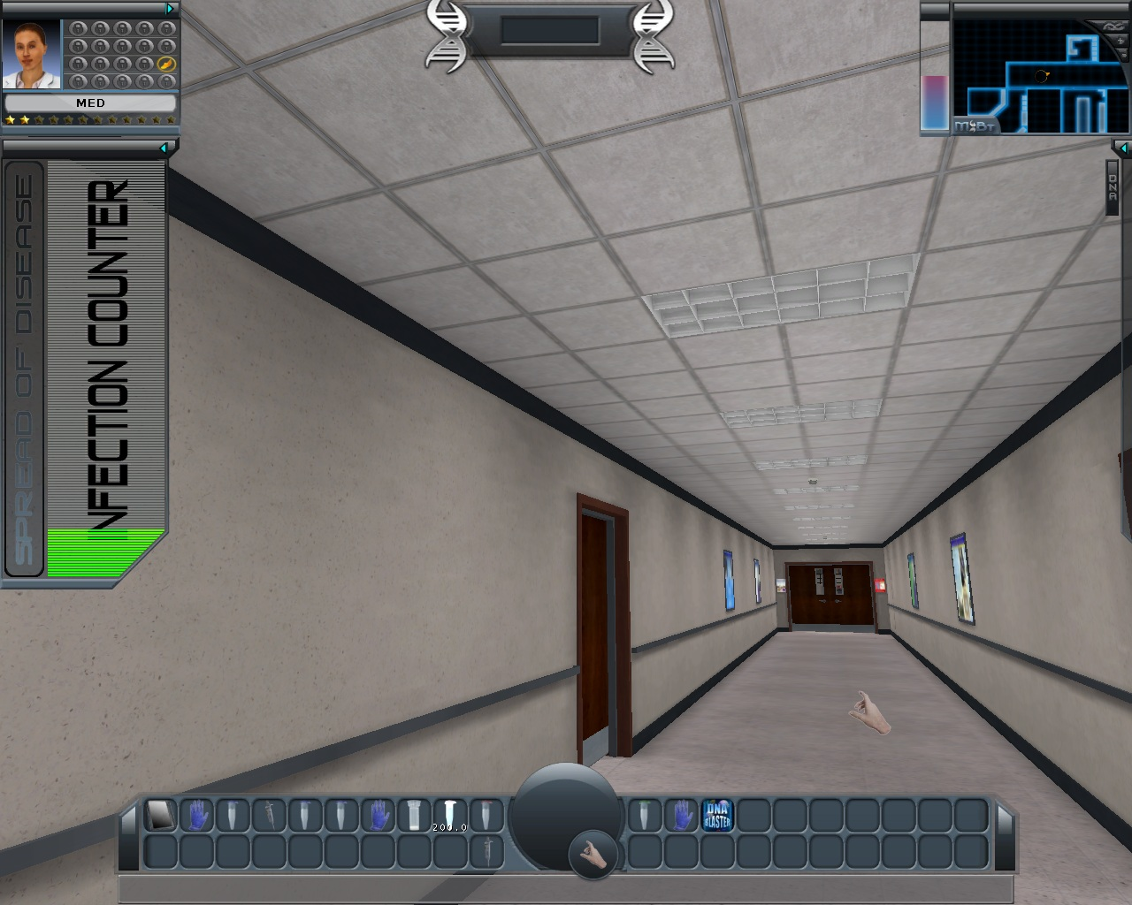

Figure 5. Graphic user interface configuration

Tutorials are found on the right side of the screen and in the logbook. The learner may at any time expand the tutorial or open the logbook to find written and video tutorials. This is a multi-functional tool for the learner. It keeps track of their experiments, completed tutorials, collect videos, collect careers, and other critical information.

Character interaction consists of pre-scripted conversation and responses to scripted questions. The characters assign tasks, provide information, recommend inquiry, and demonstrate equipment as necessary. The characters are authentic in their duties, knowledge, skill and experience.

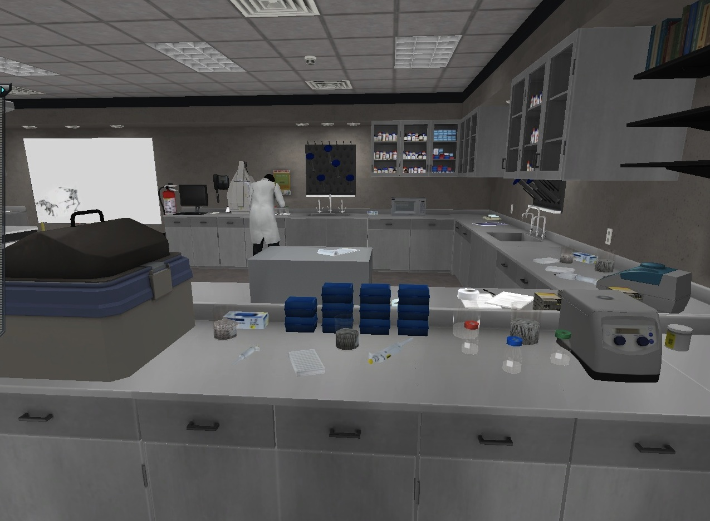
Figure 6. Learner’s workstation

Methods

The TSLE assessment team consisted of three members who played the roles of participants/observers in analyzing the Mission Biotech immersive learning environment. To explore the affordances of the game as participants/observers, the researchers downloaded and played the game as real learners. All three raters played the game individually and rated its affordances to establish inter-rater reliability. Since the game involves only a single player, no interaction with external players was possible. Therefore, each reviewer experienced the same procedures and activities during the game.
While the researchers played the game, they were involved in solving the problem presented in the environment and rating the affordances of the game. Due to the nature of the environment, and the difficulties inherent in playing a game and rating it at the same time, raters played through the game several times each. The scales in appendix A portray the scale that used for the ratings and the scores that every team member gave the game. Mainly, the following scores were used to identify the presence, absence or usage of an affordance:
  - (0) - Cognitive Affordance Not Supported
  - (1)- Cognitive Affordance Supported but Not Used
(2) - Cognitive Affordance Supported and Used
In addition to the ratings, evidence for each rating was recorded and listed in a separate column on the score sheet.. After each reviewer played the game individually and rated the TSLE, they met and discussed differences in scores. The instrument’s reliability was determined using Fleiss' kappa, incorporating ratings from all three observers. Fleiss' kappa is intended to measure reliability for instruments with categorical data and more than two observers (Landis & Koch, 1977).

Results

In general, the assigned ratings concurred on all three main categories of CATS. These results, and evidence of affordances, are detailed in Appendix A. The scores of all three raters are presented in Table 2. Overall results indicate that Mission Biotech, as a TSLE, is strongest in conceptual change, self-regulated learning, experiential learning, and active learning. Ratings also denote a profound weakness in dialogic learning, with zero marks throughout all criteria in that subscale. Fleiss' kappa for inter-rater reliability was .86, which corresponds to a near-perfect agreement (Landis & Koch, 1977). For purposes of this statistical calculation, rating of '?' by rater 3 were recoded as '1' in order to assign an ordinal value; this recoding is in accordance with the potential for those criteria to be present but their presence not being wholly in evidence, given as the description of a scale score of '1' in the instrument instructions.

Table 2. Combined ratings for each criterion.

Category |  | Score
Score Scale
  - (0) - Cognitive Affordance Not Supported
  - - Cognitive Affordance Supported but Not Used
(2) - Cognitive Affordance Supported and Used
 | Dave |  | Michelle | Ghania
Situated Learning
Experiential Learning
Inquiry Based |  | 1 | 2 | 0
Hypothesis Generation |  | 0 | 2 | 2
Experimentation |  | 2 | 2 | 2
Exploration |  | 2 | 2 | 2
Active Learning
Personally Relevant |  | 2? | 2? | 2?
Authentic |  | 2 | 2 | 2
Context Based |  | 2 | 2 | 2
Build Artifacts |  | 0 | 0 | 2
Role Playing |  | 2 | 2 | 2
Supportive Learning
Self-Regulated
Time Management |  | 2 | 2 | 2
Self-Evaluation |  | 2 | 2 | 2
Goal Setting |  | 1 | 0 | 0
Task Strategies |  | 2 | 2 | 2
Systems Support
Multiple Representations |  | 2 | 2 | ?
Feedback |  | 2 | 2 | 2
Scaffolding |  | 1 | 2 | 2
Knowledge Building
Conceptual Change
Action Reflection |  | 2 | 2 | 2
Problem Solving |  | 1 | 2 | 2
Decision Making |  | 0 | 2 | ?
Idea Generation |  | 1 | 2 | 2
Transfer |  | 2 | 2 | ?
Dialogic Learning
Collaboration |  | 0 | 0 | 0
Multiple Perspectives |  | 0 | 0 | 0
Sharing Knowledge |  | 0 | 0 | 0
Argumentation |  | 0 | 0 | 0
Articulation |  | 0 | 0 | 0

Discussion
Situated Learning
Mission Biotech scored relatively well in the overarching category of situated learning. Moreover, it was highly rated on all but one criterion of active learning, with less agreement present on the criteria for experiential learning.
The TSLE received mixed ratings on how inquiry based it was, with the selected evidence indicating, respectively by reviewer, that instruction was didactic, that learners are engaged in authentic biology lab experiments, and that the TSLE does not afford inquiry instruction because the tasks do not allow the learner to ask questions. Two of the raters indicated that MBt supported and implemented the generation of hypotheses by learners, stating that the learner is guided and given resources to create a hypothesis regarding the type of virus encountered, and that the interactions with the lab book allow the learner to predict what might happen and learn from mistakes. The first rater did not agree with this assessment, as the opportunities for hypothesis generation involved scripted, pre-constructed options rather than open opportunities for learners to make predictions from gathered information. All raters agreed that the game afforded experimentation and exploration, these being amongst the strengths of the game. The tutorial that opens play is centered around exploring the user interface and the affordances it provides, and the game itself has a strong experimentation component, as it is designed to simulate laboratory work in epidemiology, and does so reasonably well.
The three raters also concurred that Mission Biotech could be considered an authentic learning experience, as it takes place in a three-dimensional immersive environment that requires significant interaction with the tools of the lab and the problems presented. Additionally, there are authentic consequences built into the environment for failure to comply with lab safety procedures or proper handling of a biological sample, along with a character to whom results are reported. The tools themselves (hot water baths, centrifuges, and the ilk), and the settings required for success in using them, are closely matched to those that are found in a real-world laboratory of this type.
There was also considerable agreement on, and corresponding concern about the inclusion of, the criterion of personal relevance. It was deemed by all raters that the TSLE could well be personally relevant based on the description of the criterion. There existed an equal level of agreement that the environment is context-based, for many of the same reasons that it was deemed to be authentic: the environment uses a realistic laboratory setting within a plausible epidemic scenario, and couples that with an introductory news clip on recent viral outbreaks that have caused similar levels of panic (H1N1 among others). Likewise, it was agreed that the learner was asked to play the role of a working scientist, complete with journals for record keeping, communication with supervisors, and authentic laboratory procedures to follow.
Whether or not activities within the environment constitute the building of artifacts, however, was a matter of some contention. One reviewer believed that the TSLE afforded the construction of artifacts, stating that in reaching the solution to a problem the learner has to collect artifacts along the way. The other raters considered the same evidence, and made the determination that collecting artifacts is not the same as constructing them, and that the software as structured does not allow for the affordance of artifact building.
Supportive Learning
Based on the three raters’ scores, supportive learning affordances were evident in Mission Biotech with some disagreements on few subcategories.
According to the three raters, Mission Biotech supported self-regulated learning which is defined in CATS as the learners’ management of their own learning by planning, monitoring, and correcting errors without the help of others (Bransford et al., 2000; Kitsantas & Dabbagh, 2010). A TSLE that supports self-regulated learning guides the learner to maintain time management, self-evaluation, and task strategies based on CATS. In Mission Biotech, the game enforces on the learner time constraints. Learners have an onscreen display of how quickly the infection is spreading. The longer they take to complete the task, the wider the infection spreads. Therefore, the consequences that result from lack of time management could result in losing the game.
Furthermore, the learner is encouraged to self-evaluate their work along the way; the use of badges, achievements, clues, and log books allow for students to reflect on their progress and regulate their actions. Moreover, if a task is not completed correctly, the learner cannot fix the errors but has to start the task all over which allows the learner to self-reflect on his errors. Consequently, all three raters agreed that task strategies are supported in Mission Biotechnology. Each biotechnology task is carefully laid out through voice, text, and video tutorial, and then copied into a fill-in-the-blank virtual lab book before the task is completed. Essentially, each task is broken into step-by-step instructions, the learner has to reformulate those, and then follow them. However, two of the raters did not see evidence of goal setting, whereas one rater thought it was present but not used. The goals are set for the learner in what they need to accomplish at a minimum, so the learners do not have any control over the process of goal setting.
Supportive learning could also be perceived through the other of the TSLE. Systems support is defined as supportive activities that allow learners to engage with the learning process (Bransford, 2000). According to CATS, systems support is illustrated through multiple representations, feedback and scaffolding. The three raters had conflicting opinions on the presence of multiple representations in Mission Biotech. One rater could not find evidence of multiple representations whereas the two other raters thought that it is perceived and used. Raters perceived the affordance in visuals, videos, and text throughout the game. Those representations of information were reinforced by action and articulation of the learning.
Feedback is provided directly and indirectly. By moving from one stage to the other, this indicates that the learner has successfully completed a stage (indirect). When the learner takes the DNA quiz in the beginning, the accurate answers change color to yellow, and more clarification is provided to the correct answer. Also throughout the game, learners are provided with badges, ranks and verbal feedback from the game characters. Therefore the learner can imply whether a solution for a task was accurate or not.
Scaffolding is another affordance that was supported by the TSLE. Two of the raters considered it available and used whereas the third reviewer thought that it is present but not used. Scaffolding was perceived through the receptionist, the director, and the lab manager who gives instructions to the learner and can be a resource to come back to anytime the learner has a question. The characters discuss and demonstrate equipment to the learner who can get additional assistance from the posters, lab journal and videos. However, the third rater thought that the logbooks, and tutorial/walk-throughs are present as a guide, but the log book is an ever present aid rather than fading. This is probably to reduce the frustration level with complex tasks, but that doesn't make it scaffolding in the sense that it was defined in CATS.
Learners were not left on their own during game play; all raters indicated that they felt support was available when needed. At some point, the learner may express that there is no social interaction in this game, but the support that is necessary to carry on the activities is provided by other virtual characters and tools.

Knowledge Building
Mission Biotech observations overall rating indicated a support to knowledge building through conceptual change but no discernable support to dialogic learning.

Consensus on action reflection was that the environment afforded that activity; the cited evidence consisted of the ability for the learner to engage in reflection through their log/lab book, results of their performance in completing the lab (completion time and badge level changes), tutorials, and posted aids in the lab area. The learner had the option to review any tutorial they have completed (fill-in the blanks formats), any guidance they have received from the characters and observing their badge rating changes from the conduct of the experiments. The action reflection was recommended with available tools and feedback as mentioned above. The level of reflection was left to the learner. One rater noted that concept of action reflection might not be readily apparent to the rater based on direct discussion or recommendation for the learner to engage in reflection.
Problem solving received two different ratings. Two raters gave a rating of cognitive affordance supported and used and the third rater provided a rating of cognitive affordance supported but not used. Raters indicated that the affordance was used and supported cited as evidence the TSLE requiring the learner to go through the lab process properly and to determine the virus. The learner did have to engage in a complex activity, organize ideas and respond to feedback (game results and outcome). The rating of supported but not used was based on the game being scripted, and the lack of potential for the learner to actively respond to the feedback or to have the opportunity to construct an argument, therefore denying the learner the opportunity to have the full benefit of problem solving. In the closed setting of the game, the loss of dialogic learning does challenge the ability of the learner to get the full affordance of problem solving.
Decision-making also met with mixed ratings. One rater believed there was no cognitive affordance supported because of the scripted activities and interfaces in the game. One rater believed the learner did have the affordance of decision-making in determining how they prioritize their activities in the game and execute the task they needed to complete. One rater was undecided if the evidence was sufficient. The game provides the learner with several activities to complete on the first level. The learner was expected (expressed in the tutorial and Director’s instructions) to learn how to navigate within the game, use the interfaces, conduct a DNA experiment to find out what the virus was and report back to the Director. In addition to these tasks the learner was also told they needed to collect the career information from the posters in the conference room, hallway, and lab. The learner did have to make decisions on their priorities and approaches. The differences in the ratings brought into question if the level of decision-making on the first level met the rigor of the definition of decision-making. The characters did tell the learner they would receive less help in the future. Without playing to the higher level it is not discernable to know how much the decision-making complexity will increase.
Idea generation also had mixed ratings. Two raters believed cognitive affordance was supported and used and one rater believed the cognitive affordance was supported but not used. The game appeared to set the expectation that the learner generate ideas and hypotheses regarding the virus after conducting the experiment; the 'director' character also articulated that the learner was to include the information gleaned from the conducted experiments in conjunction with that obtained from the posters in the lab corridors to consider potential impacts of the experiments on the world (in virtual terms) and potential careers in biotechnology. These were cited as evidence corroborating the TSLE's affordance of idea generation. The rater who believed the affordance was not used cited the closed nature of the TSLE, which prevented dialogic learning from occurring and negated the social interaction in idea generation. The definition within the CATS addressed the aspect of social interaction. The challenge in assessing a closed TSLE lies in discerning whether the level of interaction between the learner and support structure (in this case in-game characters) is sufficient to afford dialogic learning in the manner that interaction with other learners might.
Transfer received two ratings of cognitive affordances supported and used, and one rating of uncertainty. While two raters believed that the environment afforded transfer of knowledge due to the realistic science experiments (attentions to protocols, safety, and authentic outcomes), authentic language resulting in an accumulation of skills over the course of play; the final review indicated doubt that virtual skills could be transferred to a physical laboratory setting.
Dialogic learning received an overall rating of cognitive affordances not supported. With the exception of articulation, for which one reviewer assigned a rating of "supported and used", the perception that dialogic learning was neither afforded nor able to be afforded using the current environment was unanimous. The raters’ consensus on the absences of dialogic learning was based on the closed nature of the TSLE. The game lacked any social interaction with other learners, the interaction with the characters is scripted, and collaboration was only evident with characters. The TSLE was observed by all three raters by playing the local version only so the raters cannot determine how use in a classroom might spark discussions occur after playing the game; the on-line version of the game does not afford dialogic learning differently in itself, however.

Conclusion
Overall, the application of the CATS instrument was successful in evaluating the affordances of Mission Biotech as a technology supported learning environment. Using the scale, it was possible to determine the strengths of the environment, the relative weaknesses of the environment, and how those weaknesses might be addressed. It is important to note that the high level of reliability suggests that the instrument is similarly employed by all three raters; this does not preclude some minor concerns with the instrument that arose during the analysis.
Strengths and Weaknesses of the TSLE
Mission Biotech scored consistently high in situated learning, most specifically due to the authenticity of the activities, the context in which those activities are presented, and the role adopted by the player throughout the course of the game. The game also strongly afforded experimentation and exploration. There was less consensus regarding the nature of inquiry instruction in the environment, the construction of artifacts, and the ability of users to make decisions. The last of these may be programmable in the software, but little in the game as it stands affords decision making.
In addition, Mission Biotech supported self-regulated learning well, with this being most evident in the areas of time management, self-evaluation, and task strategies. Affordance of goal setting for the learner was not apparent, and whether or not the TSLE could potentially afford the setting of goals was doubted, although not with complete consensus. The system itself was deemed to be rather supportive, with strong affordances for feedback to the learner, and what were determined to be multiple representations of the information presented. Likewise, the environment scaffolded learning to a high degree, although not all of the assistance was fading.
The TSLE also afforded conceptual change, with opportunities for action reflection, idea generation, and problem solving. Somewhat less apparent was how well the game afforded the transfer of knowledge, although the authenticity of the activities and the specific interactions indicate that it has the potential for that affordance. In the absence of observation of actual transfer, this criterion was not marked in full evidence by all raters. The most glaring weakness of Mission Biotech as a TSLE was the lack of any opportunity for dialogic learning, which was not only not afforded but not possible in either the local or online mode due to the single player nature of the game.
CATS as an Instrument
While the overall application of the CATS instrument was successful, there are a few issues that arose during the process that will need to be addressed. Firstly, it was noted by all three raters that whether or not a TSLE is personally relevant to a given learner is dependent upon that learner; assessment of personal relevance without access to learners in the course, preferably with qualitative data collection, amounts to an assessment of the environment's authenticity, making it redundant with that criterion. Of equal importance is the clarity of the rating system for the scale. It appears that scoring a '1' accurately is difficult at best without personal knowledge of how the environment can be arranged. This resulted in several criteria not being rated at all, as the affordance was not present and the potential for it to be present was unclear.
Recommendations

Based on the observations of Mission Biotech TSLE the review team had two major recommendations for the TSLE: first allowing for authentic and direct construction of artifacts, and second providing the learner-to-learner capability and forum for dialogic learning.
The first recommendation is to modify the TSLE to allow the learner to create artifacts unique to their learning experience. Currently the learner collects artifacts or generates a scripted artifact through a fill in the blank activity. An example of a learner unique artifact would be the ability to journal their learning experiences of creating (typing in) a hypothesis prior to the experiment and then comparing and reflecting (typing in) on the results of the experiment. Another example of authentic artifact is to allow the learner to complete an experiment to its conclusion even if it is incorrect. Then have the learner evaluate and record their evaluation and determine a new approach to complete the task. By adding the capability to generate learner unique artifacts the TSLE would allow for more effective inquiry based learning, hypothesis generation, building of artifacts, action reflection, decision-making, idea generation, and goal setting.
The most significant change for the TSLE is to provide learner-to-learner interaction and a forum for dialogic learning. There are multiple ways to create this environment. This could include learners being able to team with other learners in conducting the experiments and have real-time discussions during the process. Another approach is having a discussion forum on the outcome and implication of the experiment. Have ‘lab partners’ provide feedback to each other on their hypothesis and results. Have team thinking discussion on what the virus might be and how could they approach finding out. This change to the TSLE would allow for effective dialogic learning to directly enhance hypothesis generation, decision-making, problem solving, and personal relevancy.

References

Albrechtsen, H., Andersen, H. H. K., Bødker, S., Pejtersen, A. M. (2001). Affordances in activity theory and cognitive systems engineering. Available from http://www.risoe.dk/rispubl/SYS/syspdf/ris-r-1287.pdf
Annetta, L. A. (2010). The “I’s” have it: A framework for serious educational game design. Review of General Psychology, 14(2), 105-112. doi:10.1037/a0018985
Bransford, J. D., Brown. A. L., and Cocking, R. R. (2000). How People Learn: Brain, Mind, Experience, and School (Expanded Edition). Available from http://www.nap.edu/books/0309070368/html/index.html
Gaver, W.W. (1991). Technology Affordances. CHI '91 Proceedings of the SIGCHI conference on human factors in computing systems: Reaching through technology. New Orleans, USA.
Greeno, J.G. (1994). "Gibson's affordances." Psychological Review, v101(2), p. 336-342.
Kitsantas, A., & Dabbagh, N. (2010). Learning to learn with Integrative Learning Technologies (ILT): A practical guide for academic success. Greenwich, CT: Information Age Publishing.
Landis, J.R. & Koch, G.G. (1977). "The measurement of observer agreement for categorical data." Biometrics 33. pp 159-174.
University of Florida, Gainesville (no date). Mission biotech: Gaming for learning. www.missionbiotech.com. Accessed 4 December 2011.

Appendix A- Scores from all three raters

Scores from reviewer 1 with comments.

Category | Score | Evidence
Score Scale
  - (0) - Cognitive Affordance Not Supported
  - (1)- Cognitive Affordance Supported but Not Used
  - - Cognitive Affordance Supported and Used
Situated Learning
Experiential Learning
Inquiry Based | 1 | How and why are presented didactically rather than allowing the user to ask. The inability to program open-response questions in the software may mean that this should be 0 instead of 1.
Hypothesis Generation | 0 | No option for open response= no chance for generating hypotheses explicitly. It can also be argued that this is implicit throughout the game.
Experimentation | 2 | The process of solving each problem is somewhat trial and error... after some guidance is provided.
Exploration | 2 | The entire premise of the game is situated in an authentic, if slightly exaggerated, process.
Active Learning
Personally Relevant | 2 | Arguable... the topics (spread of disease) are relevant, but the more specific information may or may not be. This may represent a problem with this item rather than the TSLE.
Authentic | 2 | This is a fair representation of the processes of a biotechnology laboratory, albeit in a more movie like scenario than real-world.
Context Based | 2 | This is set in a real situation, with actual items, amounts of chemicals, and necessary settings of equipment to produce viable results. For example, the process to isolate a DNA sample for PCR is accurate to the last detail.
Build Artifacts | 0 | Not sure that the TSLE even offers this opportunity.
Role Playing | 2 | The entire game is set in the role of a biotechnology researcher that is just starting out.
Supportive Learning
Self-Regulated
Time Management | 2 | Some of the activities/levels have time limits, and consequences in game for not meeting those limits.
Self-Evaluation | 2 | The use of badges, achievements, clues, and log books allow for a student to reflect on their progress and regulate their actions.
Goal Setting | 1 | Goals are set, rather than given as options. This could be adapted by allowing the player to choose activities at different levels.
Task Strategies | 2 | Each biotechnology task is carefully laid out through voice, text, and video tutorial, and then copied into a fill-in-the-blank virtual lab book before the task is completed. Essentially, each task is broken into step by step instructions, the learner has to reformulate those, and then follow them.
Systems Support
Multiple Representations | 2 | Visuals, voice, and text throughout the game. Much of the important academic content uses all three simultaneously, followed by the opportunity for verbal and action reinforcement.
Feedback | 2 | Players are given badges, ranks, and supportive comments from in game characters. This could be stronger, as character interaction seems a bit disingenuous.
Scaffolding | 1 | The log books, and tutorial/walk-throughs are present as a guide, but the log book is an ever present aid rather than fading. This is probably to reduce the frustration level with complex tasks, but that doesn't make it scaffolding in the sense we defined.
Knowledge Building
Conceptual Change
Action Reflection | 2 | The use of log books to follow up tutorials, followed by putting the ideas into practice with the option for reviewing the directions in tab, present the opportunity for learners to reflect on how often they relied on the aids provided. This may not be readily apparent to the learner.
Problem Solving | 1 | According to this definition, problem solving does not occur because there is no chance to respond to feedback or construct arguments. This could be done with constructed dialogue, but may not be afforded at all (0) since open response isn't an option.
Decision Making | 0 | The overall plot is rather scripted here.
Idea Generation | 1 | An interesting way to present information, but no generation of new ideas is afforded, nor could it be without a social element, per our definition.
Transfer | 2 | Multiple similar situations that require the use of skills acquired during play.
Dialogic Learning |  | This TSLE lacks a social interaction element in the version examined. It is also likely that this is missing from the online version, as that is not multiplayer. Any observation of this category would have to take place in classrooms of students individually playing the game and interacting on their own, and this would not be an affordance of the technology itself, although that would be a TSLE.
Collaboration | 0
Multiple Perspectives | 0
Sharing Knowledge | 0
Argumentation | 0
Articulation | 0

Scores from reviewer 2 with comments.

Category | Score | Evidence
Score Scale
  - (0) - Cognitive Affordance Not Supported
  - (1) - Cognitive Affordance Supported but Not Used
  - (2) - Cognitive Affordance Supported and Used
Situated Learning
Experiential Learning
Inquiry Based | 2 | Learners are engaged in authentic biology lab experiments and requirements
Hypothesis Generation | 2 | Learners are required to interact in a laboratory book. This has exams, questions about what might happen. The learner has the ability to make mistakes and learn from them and to keep doing the experiment until they get it correct. The character do ask the learners to hypothesis about what might happen at certain points. What would be good if the game allowed for the learner to record this information for later reflection after the experiment was completed.
Experimentation | 2 | Learners are involved in experimentation. They are provide guides as they would be in a laboratory. However, it is up to the learners to conduct the experiments. It is evident from the characters discussion as the learner more familiar in the lab work they will receive less guidance. The learners do receive authentic feedback from the characters or the lab work. The environment and work is building.
Exploration | 2 | Learners placed in authentic lab settings, provide realistic experiments, and deal with problems that are based in science and real world situations. MBt starts with a newscast that discuss SARS and H1N1 Flu.
Active Learning
Personally Relevant | 2? | Scenarios are based on real biological situations. Pull events from the news. Provides potential career opportunities.
Authentic | 2 | Activities are anchored in science, labs, materials, and equipment reassemble real settings. The outcomes of errors are presented. Safety protocols are adhered to. Security is adhered to. Supervision is adhered to.
Context Based | 2 | Real experiments, outcomes, and problems
Build Artifacts | 2? | Results from experiments, lab book. Not sure if this is sufficient. Are they building or collecting artifacts. Will need to talk to team on definition.
Role Playing | 2 | Learner is a lab assistant/tech.
Supportive Learning
Self-Regulated
Time Management | 2 | Learners have an onscreen display of how quickly the inflection is spreading. The longer they take to complete the task the wider the infection has spread. This was interesting. In the first experiment I took the time to read all of the posters in the conference room and hallway of the laboratory. The inflection was spreading slowly. I had to repeat my experiment several times due to my errors. It increased considerably during this time.
Self-Evaluation | 2 | When the task is not completed correctly. The learner cannot revisit what they did wrong. The learner starts over. They do have the science log, the posters and tutorials if they need assistance, but they cannot revisit what they did.
Goal Setting | 0 | The goals are set for the learner in what they need to accomplish at a minimum. There are other opportunities for the learner if they choose to pursue them. Game logic. Learners cannot edit the goals in the game.
Task Strategies | 2 | Learner has to decide how to approach their tasks and how to set up their lab experiments. There are other activities in the game that could be distractors.
Systems Support
Multiple Representations | 2 | Videos, Text boxes, posters, and graphic interaction and demonstrations.
Feedback | 2 | Learners get feedback from the characters and their own actions in the laboratory
Scaffolding | 2 | Characters discuss and demo equipment to the learners. The learners have the ability to get additional assistance from the character, posters, lab journal and videos.
Knowledge Building
Conceptual Change
Action Reflection | 2 | Labs, tests, and character discussions.
Problem Solving | 2 | Labs
Decision Making | 2 | Focus on how they choose to do the lab outcomes
Idea Generation | 2 | Building from experiments and collected information from characters and career opportunities.
Transfer | 2 | Realistic science experiments and outcomes.
Dialogic Learning
Collaboration | 0 | Based on my observations they only interact with the characters. However, they are working as part of a team with the characters.
Multiple Perspectives | 0 | The learner is the lab tech and they can only interface with the tutorials, and provided information that is scripted.
Sharing Knowledge | 0 | Based on my observations they only interact with the characters. They are working as part of a team with the characters and capturing there information in their lab book/journal.
Argumentation | 0 | Based on my observations they only interact with the characters. The lab book and the game has pre-scripted questions, considerations, and discussions/dialogue. The learner is choosing from game presented arguments/ selections.
Articulation | 0 | Based on my observations they only interact with the characters and with the pre-scripted dialogues.

Scores from reviewer 3 with comments.

Category | Score | Evidence
Score Scale
  - (0) - Cognitive Affordance Not Supported
  - (1) - Cognitive Affordance Supported but Not Used
  - (2) - Cognitive Affordance Supported and Used
Situated Learning
Experiential Learning
Inquiry Based | 0 | I didn’t observe this affordance because the tasks do not trigger the learner to ask questions. In the lab activity for instance, the learner is provided with the answers from the quiz, so he doesn’t have to ask the lab manager.
Hypothesis Generation | 2 | The learner is guided and given resources to generate a hypothesis of what type of virus does the patient carry.
Experimentation | 2 | The learner is guided to experiment by extracting DNA sample and testing it. It is a hands-on activity.
Exploration | 2 | In the beginning of the game, the learner is asked to explore the controls of the game, the tools, the setting, and how to play the game. The exploration is a kind of an orientation to the game. Also the learner is guided to explore the tools that he will use in the experiment. By clicking on a relevant tool, the learner explores its affordances in the experimentation process.
Active Learning
Personally Relevant | 2? | It depends on whether the learner in interested in biology or not.
Authentic | 2 | The activities take place in a real 3D lab where the learner interacts with the tools and the environment. The learner acts as if he is in a real lab where gloves are necessary, mistakes have consequences, and a lab manager to whom the results are reported is present.
Context Based | 2 | The activities are very meaningful; the learner can learn a lot from this activity that can be applied in a real lab.
Build Artifacts | 2 | It is more reaching a solution to a problem. Along the way, the learner has to collect artifacts to be able to solve the problem.
Role Playing | 2 | The learner is a lab assistant. He interacts with the lab manager, the receptionist, and the director along the way.
Self-Regulated
Time Management | 2 | A time keeper appears on the screen to show the learner how many more people are getting infected with the virus. The longer it takes the learner to figure out what the virus is, more people will be infected with the virus which forces the learner to work faster. I found this way of time management to be very meaningful where the learner feels more responsible for his actions.
Self-Evaluation | 2 | The learner evaluates his learning indirectly by moving from a level to another.
Goal Setting | 0 | The learner is not provided the opportunity to set goals. He needs to conduct the tasks assigned to him and has no control over setting his goals.
Task Strategies | 2 | The tasks are already broken down for the learner based on Bloom’s taxonomy
Systems Support
Multiple Representations | ?
Feedback | 2 | Feedback is provided directly and indirectly. By moving from one stage to the other, this indicates that the learner has successfully completed a stage (indirect). When the learner takes the DNA quiz in the beginning, the accurate answers change color to yellow, and more clarification is provided to the correct answer.
Scaffolding | 2 | Is presented through the receptionist, the director, and the lab manager. Also it is presented through the lab book, and the posters.
Conceptual Change
Action Reflection | 2 | When the learner applies what he learned in the experiment, he is reflecting on his learning.
Problem Solving | 2 | The learner is solving the problem of a virus of an unknown nature using resources and clues.
Decision Making | ? | I got to the point where the learner is doing the DNA extraction. Up until that point there were no signs of decision making.
Idea Generation | 2 | The learner is able to generate new ideas about the virus after the experiment is conducted
Transfer | ? | I am not sure whether transfer can happen here. The learner is always interacting in virtual environment. There is no evidence that the learner could transfer the learning into a real-life situation.
Dialogic Learning
Collaboration | 0 | The learning is scaffolded by the characters but the learner has to carry the tasks on his own. Although the game mentions ranks, however, the learner is playing with the program itself.
Multiple Perspectives | 0 | There aren’t multiple viewpoints in this game. The learner is playing alone and interacting with existing resources.
Sharing Knowledge | 0 | The learner shares information with the characters created by the program itself, and sometimes hares his knowledge with the lab book.
Argumentation | 0 | The character is just providing correct/wrong answers, no argumentation to prove a point.
Articulation | 2 | Articulation of results

