**Ghania Zgheib -**

**EDRS 811**

**Lab # 1**

***Scenario***

A study was conducted to determine the effectiveness of three methods of teaching math to third graders that was instituted three years ago at Garvey Elementary School. Students 40 students were randomly selected from the third grade classes and then ten (10) students were randomly assigned to one of three teaching methods: computer-base math instruction; math instruction using various three-dimensional objects (*manipulatives*); math instruction using a combination of the use of the computer and manipulatives. A fourth group of students remained in their original classrooms where math instruction was based primarily on the textbook. All groups received the same units of instruction for a period of ten weeks. At the end of the tenth week, students took a teacher-made math test that assessed their comprehension and problem solving skills in the topics covered during instruction. All students were administered a brief Likert-formatted interest scale to measure their level of interest in math. The researchers were also interested in whether there were differences in the students’ interest in math among the four groups, and if there were a relationship between math performance and math interest.

*Reflections:* From the scenario given above -

1. Identify the Independent Variable(s):Math interest
2. Identify the Dependent Variable(s):Math performance
3. Write an appropriate research hypothesis for the study: There are differences in the students’ interest in math among the four groups, and there is a relationship between math performance and math interest.

*Data Entering Phase I: Variable Specifications*

1. Open SPSS then click in the small circle indicating you will *Type in Data*. Click *OK*.
2. You will now see a spreadsheet similar to Excel. This is the sheet where you will enter your data. But first, we must tell SPSS about the nature of the information to be entered. At bottom left you will find two tabs. Click on the *Variable View* tab.
3. A new spreadsheet will appear for entering information about each variable to be entered into the SPSS data sheet.
4. Enter the information listed in Table 1 for each variable.

Table 1 lists each variable along with its column location, type, value ( if coding is involved), and measure (nominal, ordinal or scale). In SPSS, *type* refers to the format of the data to be analyzed. Your choices are *string* for variables whose levels are distinguished by the use of words (for example, male or female; old or new; low, middle, high, etc.) or *numeric* if distinguished by numbers. Other types include entering values in dollar, date, and scientific notation format.

Table 1. Data Definitions for Fictitious Study

Variable Location Type Value Measure

Person 1 string (none) nominal

Sex 2 string 1= female nominal

2= male

Group 3 string 1= compAsst non nominal

2= Manipt

3= Combo

4= Textbase

Mathscor 4 numeric (none) scale

MathInt 5 numeric (none) scale

*Data Entering Phase II: Data Input*

Now we are ready to enter the actual data.

1. Click the *Data View* tab at the bottom-left.
2. Enter the data as listed in Table 2. Name the file Mathstudy and save it (frequently) to your storage medium.

Table 2. Data for Fictitious Math Study

|  |  |  |  |  |
| --- | --- | --- | --- | --- |
| ID | Sex | Group | MathScor | MathInt |
| 1  2  3  4  5  6  7  8  9  10  11  12  13  14  15  16  17  18  19  20  21  22  23  24  25  26  27  28  29  30  31  32  33  34  35  36  37  38  39  40 | male  male  male  male  male  female  female  female  female  female  male  male  male  male  male  female  female  female  female  female  male  male  male  male  male  female  female  female  female  female  male  male  male  male  male  female  female  female  female  female | 1  1  1  1  1  1  1  1  1  1  2  2  2  2  2  2  2  2  2  2  3  3  3  3  3  3  3  3  3  3  4  4  4  4  4  4  4  4  4  4 | 44.55  51.46  46.73  51.79  48.41  40.90  61.51  49.50  40.18  59.28  43.78  60.07  49.22  67.23  39.11  54.35  53.82  35.30  28.52  70.66  37.50  40.20  55.92  59.63  50.64  48.79  56.94  37.65  42.99  50.54  50.60  54.29  36.77  49.77  42.77  65.04  54.63  71.52  65.31  43.75 | 3.39  4.84  4.39  3.87  2.24  2.87  5.50  3.69  3.20  4.83  1.74  5.00  4.23  4.55  4.26  5.00  3.02  3.77  3.34  4.31  3.85  3.46  3.03  3.24  2.09  3.94  4.47  3.95  1.47  3.48  4.86  4.20  4.33  2.92  3.20  3.69  4.10  3.17  4.29  5.00 |

*Data Entering, Phase III: Computing a New Variable*

Sometimes it’s necessary to transform an existing an existing variable into another metric. For example, age expressed as months may be recalculated so to be expressed in terms of years; inches into feet, and so forth. Let’s do an operation with our data that will transform our variables of interest (math test scores and math interest scale scores) into other variables. For reasons to be discussed later, suppose we decide to subtract the **mean** of the entire sample’s math test score from each person’s individual score (e.g., person #1 score – Mean of the math test scores) then divide the difference by the **standard deviation** of the test scores. We can name the resulting variable, *mathscsorez* to make a distinction with the original variable.

*Procedure*

To compute a new variable from the math test score variable, follow this procedure:

1. Select the SPSS procedure, **Transform**, from the top menu then
   1. Click on *Compute Variable* which will open a dialogue window with a list of the existing variables, a calculator-like key pad, and an empty window preceded by the equal (=) sign for entering mathematical operations. In the window titled “ Target Variable,” type the name for the new variable. Type *mathtestz*. This variable has a mean = 50.29 and a standard deviation = 10.13.
   2. Select the parenthesis ( *()* ) expression on the key pad. The expression will appear in the calculator window. Place the cursor in the center of the parenthesis.
   3. Highlight the existing variable, *math test score*, then move it to the cursor position in the calculator window by clicking the arrow located in the center of the dialog window.
   4. Select the subtraction sign ( - ) on the key pad then type 50.29.
   5. Select the division sign ( **/**) then type the value 10.03.
   6. Click OK.
   7. Go to Data View and check for a new variable, *mathtestz*, with values for each student.
   8. Save your SPSS file fr
2. *Follow-up*: The variable *math interest scale score* has a mean = 3.77 and a standard deviation = 0.92. Compute a new variable, *mathintz*, from this existing variable.
3. Check for accuracy. Both of the new variables should have means close to zero and standard deviations close to 1.00. To check for this,
   1. Select the SPSS procedure, Analyze, found at the top menu.
   2. Click on *Descriptive Statistics* then *Descriptives*. A dialogue window will open that lists the variables in the data set.
   3. Hold down the control key (*Ctrl*) and select the two new variables.
   4. Move them to the empty window on the right by clicking the arrow found in the center of the dialogue window.
   5. Click OK.
   6. Inspect the output to confirm the values for the means and standard deviations for the two variables. Are the means approximately zero? Yes. Are the standard deviations approximately 1.00? Yes.

________________________________________________________________________

**Lab # 2**

**Math Study Statistics**

**3. Interpreting the output**

b. The next section displays the summary statistics for math test scores and math interest scale scores for the 40 students. Use the table to answer the following questions.

* 1. Compare the mean and median for the math test scores. Which average is the largest, the mean or median? _____mean________. What does this difference imply about the skewness of the salary distribution?_____ positively skewed____________
  2. Fifty percent of the students had math test scores below what value? 50.16
  3. The most reoccurring test score value is ____there’s no mode
  4. Assuming that the mean is the *model* to represent the two variables for all students,
     1. For which variable, Math test scores or math interest scale scores does the mean best fit the model? ________________.
     2. Explain your answer:
  5. Which distribution, math test scores or math interest scale scores, has the greatest degree of “peakedness?” ___Math Interest Scale __. Explain your answer

Math interest scale kurtosis is higher

* 1. Using a hand calculator or the one provided in PC Windows, divide the Std. Deviation of the *math test scores* by the square root of the sample size (n=40). Record the value here:_1.62 _. Identify this value in the column for *math test scores*. What is the name for this statistic?____ standard error of mean___
* This statistic indicates that if we were to take more samples (an infinitely large number of samples) with the same number of employees (n = 40), we can expect the average difference in the sample mean salaries would be roughly ____.
* Using this logic, write an explanation for the Std. error of the mean for the *Math interest scale score*  variable:

This statistic indicates that if we were to take more samples (an infinitely large number of samples) with the same number of employees (n = 40), we can expect the average difference in the sample mean math interest scale would be roughly ________________________________

* 1. The top 25% of the students have *math test scores* at or above what value? 56.69
  2. Click anywhere in the body of the table. A red arrow and border will appear around the table. Left-click and select “copy.” Paste the table below.

|  |  |  |  |  |  |  |  |  |  |  |  |  |  |  |  |  |  |  |  |  |  |  |  |  |  |  |  |  |  |  |  |  |  |  |  |  |  |  |  |  |  |  |  |  |  |  |  |  |  |  |  |  |  |  |  |  |  |  |  |  |  |  |  |  |  |  |  |  |  |  |  |  |  |  |  |  |  |  |  |  |  |
| --- | --- | --- | --- | --- | --- | --- | --- | --- | --- | --- | --- | --- | --- | --- | --- | --- | --- | --- | --- | --- | --- | --- | --- | --- | --- | --- | --- | --- | --- | --- | --- | --- | --- | --- | --- | --- | --- | --- | --- | --- | --- | --- | --- | --- | --- | --- | --- | --- | --- | --- | --- | --- | --- | --- | --- | --- | --- | --- | --- | --- | --- | --- | --- | --- | --- | --- | --- | --- | --- | --- | --- | --- | --- | --- | --- | --- | --- | --- | --- | --- | --- |
| | **Statistics** | | | | | --- | --- | --- | --- | |  |  | Math test | Math interest scale | | N | Valid | 40 | 40 | | Missing | 5 | 5 | | Mean | | 50.2905 | 3.7695 | | Std. Error of Mean | | 1.60115 | .14588 | | Median | | 50.1550 | 3.8600 | | Mode | | 28.52a | 5.00 | | Std. Deviation | | 10.12659 | .92264 | | Variance | | 102.548 | .851 | | Skewness | | .206 | -.535 | | Std. Error of Skewness | | .374 | .374 | | Kurtosis | | -.359 | .124 | | Std. Error of Kurtosis | | .733 | .733 | | Range | | 43.00 | 4.03 | | Minimum | | 28.52 | 1.47 | | Maximum | | 71.52 | 5.50 | | Percentiles | 25 | 42.8250 | 3.2000 | | 50 | 50.1550 | 3.8600 | | 75 | 56.6850 | 4.3750 | | a. Multiple modes exist. The smallest value is shown | | | | |

1. The next section of the SPSS output provides **an ungrouped frequency table** for the two variables. It should be obvious that this table is only useful as a way to visually inspect our data. It indicates the number (frequency) of students making each test score listed in the data view. It also expresses the frequencies in terms of percentages of the total sample size (n=40) or an adjusted total if there were no scores recorded for some students. In this case, this was not the case, so the percents and valid percents are identical. For ease of reading, the percents are provided as cumulative percents in the fifth column.
   1. Reading down the column to the cumulative percent of 75.1. What salary do you find? $_______________.
   2. Looking back at the first table, do you find a salary in the beginning salary column that is close in value? What statistic does this salary represent?______ I think there’s an error in question 1.
2. Chart Type 1: The Histogram. The histograms for the two variables, Math test scores and Math interest scale scores should be part of the output.

* Describe the shape of the two distributions as shown by their respective histograms (near symmetrical, positively skewed, negatively skewed).

The distributions are near symmetrical which indicates that there’s a normal distribution of math scores and math interest.

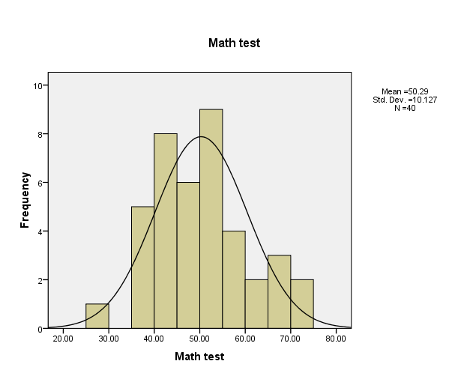

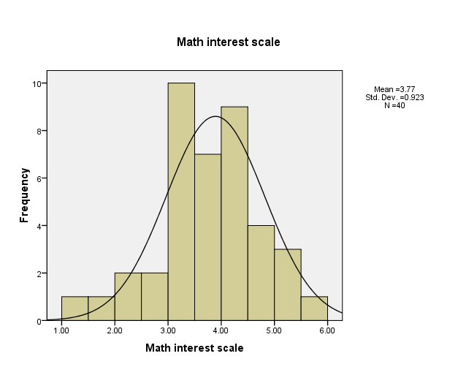

_____________________________________________________________________________________

**Lab # 3**

Let’s develop the SALTs for the math test scores and math interest scale scores separately for males and females

1. Go to **Analyze** -> **Descriptive Statistics -> Explore**
2. Move the variables**,** *math test scores* and *math interest scale scores***,** to the **Dependent List** window by highlighting them and clicking on the **Dependent List Arrow.**
3. Move the variable**,** *sex***,** to the **Factor List** window by highlighting it and clicking the arrow for that specific window.
4. Make sure that the **“Both”** radio is on in the **Display** section then click **OK.**
5. Open up space below then copy and paste the four SALTs . Compare males’ and females’ math test scores in terms of:
   * Shape of the salary distributions (what are the characteristics of distributions that we use to describe them?)
   * Test score ranges
   * Estimated the *median* and *modal* scores
   * *Repeat i-iii for math interest scale scores*
   * Write a paragraph summarizing your findings for comparing males and females math test scores **and** math interest scale scores based on the information provided by the SALTs.

|  |  |  |
| --- | --- | --- |
|  | Males | Females |
| Test score |  |  |
| Range | 36-67 | 20-71 |
| Median |  |  |
| Mode | Trimodal | trimodal |
| Interest |  |  |
| Range |  |  |
| Median |  |  |
| Mode |  |  |

Math test Stem-and-Leaf Plot for

Sex= female

Frequency Stem & Leaf

1.00 2 . 8

2.00 3 . 57

6.00 4 . 002389

6.00 5 . 034469

3.00 6 . 155

2.00 7 . 01

Stem width: 10.00

Each leaf: 1 case(s)

Math test Stem-and-Leaf Plot for

Sex= male

Frequency Stem & Leaf

3.00 3 . 679

4.00 4 . 0234

4.00 4 . 6899

5.00 5 . 00114

2.00 5 . 59

1.00 6 . 0

1.00 6 . 7

Stem width: 10.00

Each leaf: 1 case(s)

Math interest scale Stem-and-Leaf Plot for

Sex= female

Frequency Stem & Leaf

1.00 Extremes (=<1.5)

1.00 2 . 8

5.00 3 . 01234

5.00 3 . 66799

4.00 4 . 1234

1.00 4 . 8

2.00 5 . 00

1.00 5 . 5

Stem width: 1.00

Each leaf: 1 case(s)

Math interest scale Stem-and-Leaf Plot for

Sex= male

Frequency Stem & Leaf

1.00 1 . 7

3.00 2 . 029

7.00 3 . 0223488

8.00 4 . 22233588

1.00 5 . 0

Stem width: 1.00

Each leaf: 1 case(s)

**B. Chart III: The Boxplot.** Dimitrov refers to specific points in a score distribution as noteworthy: the 25th, 50th, 75th percentiles. They are also designated Q1, Q2, and Q3, respectively. Also worth inspecting is the lowest (minimum) and highest (maximum) scores in a distribution. These various points are summarized in the boxplot. Moreover, the range within the distribution that lies between Q1, and Q3, the interquartile range (IQR) conveys important information regarding the variability of the center of the distribution.

1. Return to your SPSS output file and scroll down to the charts found after the Stem and Leaf Tables for math test scores and math interest scale salaries. The two rectangles with the extensions (whiskers) are referred to as **boxplots** in SPSS. **Figure 3** illustrates the anatomy of the boxplot. There are three types of box plots provided by SPSS: the *simple boxplot, the clustered boxplot, and the 1-D Boxplot.*
   1. Your output gives a simple boxplot used to depict distribution features for a single variable (math test scores), but where you wish a separate box plot for different categories of another variable (sex).
   2. The *clustered* boxplot is an extension of the simple boxplot in that you may include a second categorical variable to subdivide your data. For example, we could drill deeper in our comparison of male and female salaries by adding *groups.*
   3. The 1-D (or one dimensional) box plot is used when you are interested depicting the characteristics of the overall distribution without consideration of other variables.
   4. In SPSS click on **Graphs -> Chart Builder -> Choose from**: **Boxplot** you will see an example of the three types of Boxplots.
2. The anatomy of the boxplot is given in Figure 3. We see that the top of the box represents the 75th %-ile (upper quartile) and the lower edge, the 25th %-ile (lower quartile). Therefore, the height of the box encompasses the middle 50% of the score distribution. The middle 50% is called the interquartile range (IQR). The line that bisects the box is the median (50th %-ile). The whiskers extend downward and upward to capture the minimum and maximum score values, respectively, *but no longer that 1.5 times the height of the box*. Any score values found beyond the whiskers are considered “outliers” and should be investigated. The data ID number identifies the outliers in SPSS. We see in Figure 3 that male subject #231 was identified as an outlier on the reading T-score scale.

**Figure 3. Anatomy of the Boxplot**



Upper quartile

Median

Lower quartile

Top 25%

Bottom 25%

*231

1. Boxplots with whiskers of equal length and where the median bisects the box exactly in half suggest a symmetrical distribution.
2. Make space below. Copy the boxplots from your SPSS output and past in this section. After pasting the boxplots, examine them and answer the following questions:

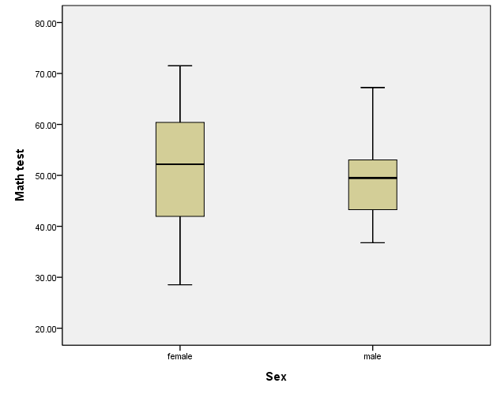 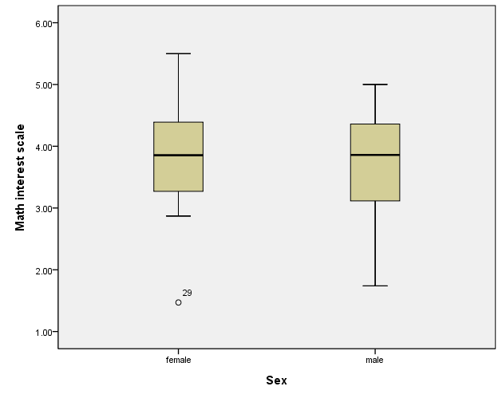

* 1. What is the *interquartile range* ( IQR) for the math test scores? Females: 52, Males: 49. For the math interest scale scores? Females: 3.8, Males: 3.8.
  2. What are the *reasonable upper boundaries* (RUB) and *reasonable lower boundaries* (RLB) for the two variables, respectively? Math Test: Female (RUB) 72, Male (RUB) 67, Female, (RLB) 42, Male (RLB) 43…. Math Interest Scale: Female (RUB) 5.5, Male (RUB) 4.9, Female, (RLB) 3.2, Male (RLB) 3.
  3. Are there any *outliers* in either score distribution? One outlier for females (29) on the math interest scale.
  4. Approximately what is the *math test score* for females at the 75th %-ile? 60. For males at the 75th %-ile? 52.
  5. Approximately what is the *math interest scale score* for females at the 75th %-ile? 4.3. For males at the 75th %-ile? 4.2.
  6. Write a descriptive narrative of your findings from the answers a-e above. Include a statement that includes the number of individuals involved in the analysis: It appears that females tend to do better on the math tests than males do. In terms of math interest, it seems quite similar between females and males. There was one outlier on the math interest scale among females on the low end.

_____________________________________________________________________________________

**Lab # 4**

Resources: Dimitrov, Chapter 6

SPSS files: (1) **Mathstudy**

(2) **Employee data.sav**

Learning Outcomes:

* To gain understanding general nature of standard scores
* To be able to compute z and T scores using appropriate scale transformations

**Review**

Recall that the basic standard score (z) is a statistical expression for describing a score or quantitative observation in terms of its relative position in a score distribution. In this case, the score is interpreted in terms of how far it lies from the *mean* of the distribution in *standard deviation units*. As a formula, we have:

**z = (Score – Mean)/SD = (X – Mean)/SD (1)**

Therefore, if Kim has a reported score of 4 on a questionnaire based on a five-point Likert scale where the survey sample shows a mean of 3.8 and a standard deviation of 0.35, we can report that her survey score (X=4.0) is equivalent to a z-score of

**z = (4.0 -3.8)/0.35 = 0.57**

Since the z-score is reported in standard deviation units, we can report Kim’s survey score as 0.57 units above the mean of the survey sample. If the z-score had been *negative* in value, it would denote that her reported survey score was *below* the mean of the sample. The *magnitude* of the z-score tells us *how far*  the reported score lies from the mean, and its sign indicates whether it lies above ( + ) or below ( - ) the mean.

When original scores are transformed to z scores the mean and standard deviations are transformed as well. The mean for any distribution of z-scores is equal to 0.0 and the standard deviation is equal to 0.0. If this sound familiar, it’s because you already computed the z score scores for the math test scores and the math interest scale scores in the math study you began in Lab #1. Z scores usually range in value from -3.0 to +3.0.

The z score is basic to the development of other standard scores. For example, another standard score is the T-scale (TS) score that can be determined by: TS = z*10 + 50. The TS score distribution ranges from 20 to 80. As you note, the distribution does not contain negative values and therefore more desirable for reporting results to the public.

Procedure.

1. Open your math study file. Select Transform from the menus at the top. Click Compute Variable.
2. Type mathtestT for the name of the target variable.
3. Select mathtestz from the list of variables and move to the Numeric Expression box by clicking the arrow located in the center of the dialog window.
4. Complete the operation by multiplying mathtestz by 10 then adding 50. The box should look at this:

**mathtestz *10 + 50.**

1. Click OK then inspect the new variable in the data view.
2. Confirm that the new variable, mathtestT has a mean of 50 and a standard deviation of 10 by using the Analyze-🡪 Descriptive Statistics🡪 Descriptives procedures.
3. Repeat the process for the math interest scale z scores previously computed I Lab #1.
4. Compare the shapes of the original math test scores, the math test z-scores, and the math test TS scores by generating histograms for each distribution. What conclusion can you draw from this comparison? They all look normal distributions.
5. Write a descriptive paragraph summarizing your finding. Compare with your study mate’s paragraph. Revise as necessary:

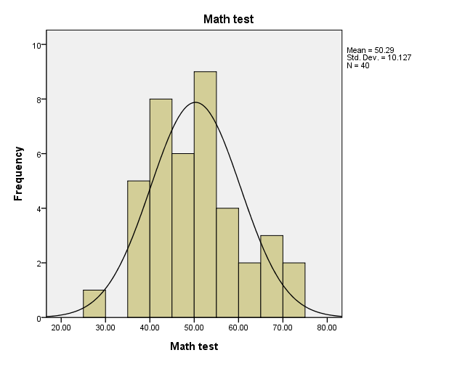 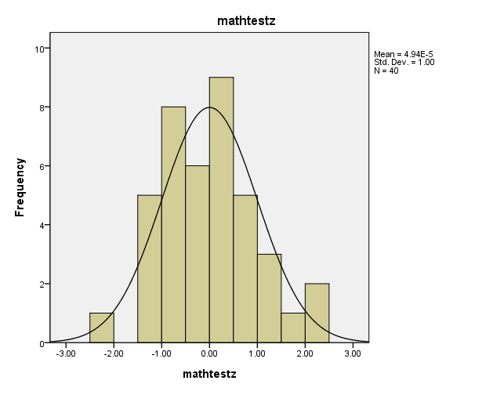

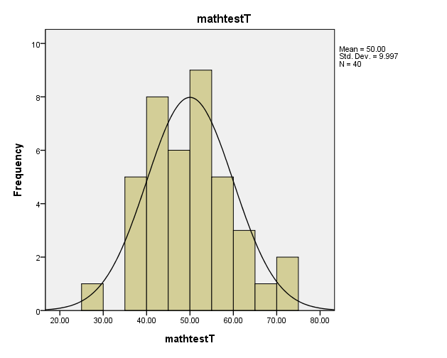

**_____________________________________________________________________________________**

**Lab # 5**

**Objectives – Students will be able to**

* **To make accurate interpretations of the normal curve table**
* **Determine the percentiles for specified points under the normal curve**
* **To assess how well sample data conforms to the normal curve**

**Activities**

**Use Appendix A-1 to complete the following activities**

Determine the proportion of the curve located to the right of the following z-scores:

z = 1.65 – 50%

z = 1.98- 76%

z = -1.65- 50%

z = - 1.00 – 84.1%

z = 2.00 – 77%

Determine the z-scores for the following percentiles

50th percentile: 1.65

95th percentile: 1.31

40th percentile: 1.75

99th percentile: 1.29

Occasionally it is important to investigate whether a sample distribution

conforms to the normal curve. Intuitively, if the percentiles, deciles, quartiles, etc. , and their corresponding z-scores show a similar patter as found in the normal curve table we can be confident that it does. Rather than computing the values by hand, we can use SPSS to provide a chart that shows the relationship of the percentiles for your sample data with the normal curve. We can have SPSS to match the two sets of **quantiles** (e.g., percentiles, quartiles, deciles): your sample data and **the normal quantiles** specified in the normal table**.** This type of plot is called **a normal Q-Q plot.**

Retrieve your math study data in SPSS.

Click Analyze ­­-🡪---Descriptive Statistics -🡪 Q-Q Plots

Move both the math test score and math interest scale score variables to the Variables box.

Click OK

Examine the two Normal Q-Q plots.

**Write a brief description of your findings.**

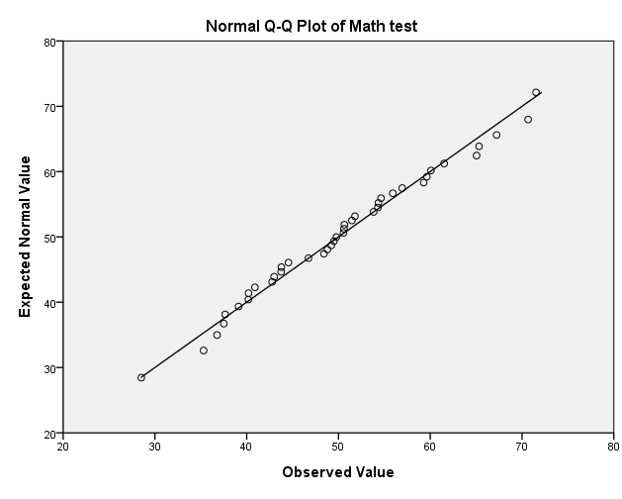

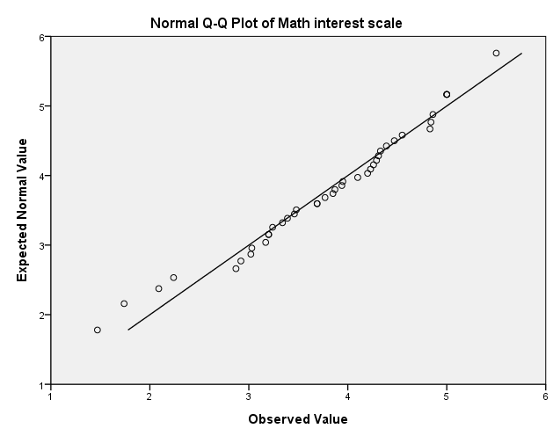

Both the normal Q-Q plots of the math test and the math interest scale appear to be normally distributed for the most part because the dots lie close to the straight line.

**______________________________________________________________________________**

**Lab # 6**

The results from the one-sample t-test shows that there is no statistical a statistically significant see page 106

If the CI includes the null hypothesis

Range is about

95

CI +( 102-15.58) – (102+3.3) =

P=.2

p

| **One-Sample Statistics** | | | | |
| --- | --- | --- | --- | --- |
|  | N | Mean | Std. Deviation | Std. Error Mean |
| Previous Experience (months) | 474 | 95.86 | 104.586 | 4.804 |

| **One-Sample Test** | | | | | | |
| --- | --- | --- | --- | --- | --- | --- |
|  | Test Value = 102 | | | | | |
| t | df | Sig. (2-tailed) | Mean Difference | 95% Confidence Interval of the Difference | |
| Lower | Upper |
| Previous Experience (months) | -1.278 | 473 | .202 | -6.139 | -15.58 | 3.30 |

The results from the one-sample t-test show that there is no statistically significant difference between the mean educational level of employees and the hypothesized value of 102 months, t(473)=-1.278 month. Since the p value is .202 is greater than the level of significance (α=.05) therefore we fail to reject the null hypothesis H˳:µ=102. The 95 percent confidence interval for this difference shows that on average, the mean educational level of the employees falls within the confidence range (86.42 – 105.30) with an upper limit of 3.30 and a lower limit of 15.58.

**______________________________________________________________________________**

**Lab # 7**

**Laboratory Procedures**

Preliminary (But Critical) Steps:

1. State the *research* hypothesis in symbolic form for research question #1: Ha: M>7.5
2. State the *null* hypothesis in symbolic form for research question #1: Ho: M=7.5
3. State the *research* hypothesis in symbolic form for research question #2: Ha: M1>M2
4. State the *null* hypothesis in symbolic form for research question #2: Ho: M1<M2
5. Specify the error level (Type 1) you are willing to tolerate (0.05 or 0.01) if you incorrectly reject a true null hypothesis: α = 0.05
6. Enter the raw data and make sure that each variable is set at the appropriate level of measurement (nominal, ordinal, or scale)
7. Decide which inferential statistical test is appropriate for testing the null hypothesis:
   1. (Complete the sentence). The *single-sample t test* was selected for the first inferential statistical analysis because

We are comparing the mean of one sample to a hypothetical population; or we want to figure out whether the sample is representative of a population

* 1. (Complete the sentence). The *t test* for differences in means for *independent samples* was selected for testing the second null hypothesis because We are testing whether or not the populations of males and females, if in fact their mean hours are equal.

| **One-Sample Statistics** | | | | |
| --- | --- | --- | --- | --- |
|  | N | Mean | Std. Deviation | Std. Error Mean |
| Hours Spent on Essay | 45 | 8.3490 | 2.72545 | .40629 |

| **One-Sample Test** | | | | | | |
| --- | --- | --- | --- | --- | --- | --- |
|  | Test Value = 7.5 | | | | | |
| t | df | Sig. (2-tailed) | Mean Difference | 95% Confidence Interval of the Difference | |
| Lower | Upper |
| Hours Spent on Essay | 2.090 | 44 | .042 | .84902 | .0302 | 1.6678 |

1. What is the ***critical (tabled) valu***e for the t-statistic that should be used to assess the null hypothesis for this study? 2.021
2. What does the 95% Confidence interval tell us about the sampling distribution? The difference extends between .0302 and 1.6678.
3. Accept (A) or Reject (R) the null Hypothesis? __R_ Why? P<.05
4. What is the ***critical (tabled) valu***e for the t-statistic that should be used to assess the null hypothesis for this study? 2.021
5. What does the 95% Confidence interval tell us about the sampling distribution? The difference extends between .0302 and 1.6678.
6. Accept (A) or Reject (R) the null Hypothesis? __R_ Why? P<.05