Ghania Zgheib
Curiosity Memo
EDRS 812
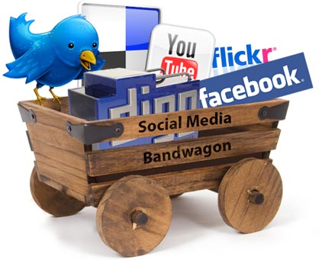
The spread of social media has impacted the way people learn and interact with each other. This phenomenon has brought to surface inquisitions on how people benefit from this interaction and how it might impact their knowledge and education. Many research studies have highlighted the benefits of social media in education, however, I would like to understand how faculty use social media in their teaching and how it impacts the students’ learning. Initially, my interest in this topic started through my own teaching practices in which I use social media tools as learning platforms to facilitate communication with the students and among themselves in addition to using social media to share class activities and assignments. I implemented these tools to encourage students’ interactions and to help them improve their English language skills, but I could not tell how the use of blogs, wikis, and Facebook have influenced their learning. To understand this phenomenon, I am planning to conduct a pilot study in Fall 2012.
Some studies have reported a positive relationship between the use of Web 2.0 technologies and students’ GPAs (Junco, 2012) whereas others reported a negative correlation between both variables (Kirschner & Karpinski, 2010). On the other hand, social learning theories have highlighted the importance of social interaction in development and learning, and recent publications explain social learning theories as applied to our contemporary society. Some studies (Chen & Bryer, 2012) have highlighted ways in which faculty members use Web 2.0 tools but they have not discussed learning activities that are assigned through social media and whether these specific learning tasks enhance student learning. With the increasing use of social media in education (Dabbagh and Kitsantas, 2012), I would like to investigate several questions:
- What are the most common social media tools that faculty use in their teaching at GMU?
- What are the most common tasks that faculty assign for students to complete through social media?
- Does social media enhance student learning?
- What learning activities that faculty assign through social media enhance student learning the most from their perspective?

References
Casey, G. & Evans, T. (2011). Designing for learning: Online social networks as a classroom
Environment. The International Review of Research in Open and Distance
Learning, 12 (7), 1-26.
Chen, B. & Bryer, T. (2012). Investigating instructional strategies for using social media in
formal and informal learning. The International Review of Research in Open and Distance
Learning, 13(1), 87-104.
Dabbagh, N. & Kitsantas, A. (2012). Personal Learning Environments, social media, and self-
regulated learning: A natural formula for connecting formal and informal learning. Internet
and Higher Education, 15, 3–8.
Junco, R. (2012). Too much face and not enough books: The relationship between multiple
Indices of Facebook use and academic performance. Computers in Human Behavior, 28,
187–198.
Kirschner, P. A., & Karpinski, A. C. (2010). Facebook® and academic performance. Computers
in Human Behavior, 26(6), 1237-1245. doi:16/j.chb.2010.03.024

