Team 1
Members: Nof Al Haj, Ghania Zgheib & Dave Lord
E-learning/Training Module
Topic: Culture and e-learning
International students who come to the United States seeking a US diploma are faced with several academic as well as transitional challenges (Mallett & Zgheib, 2011; Zhou, 2004). Among those challenges are language requirements, study skills such as note-taking, time management, understanding course requirements or the process for achieving course goals, making American friends, understanding the American culture, homesickness, and intercultural communication. Those challenges lead students to frustration and culture shock that delays their academic achievement and impacts their lives in different ways. Zhou (2004) reports that international students are more at risk of committing suicide than domestic students. Not only that, as we can see in figure 1, the number of international enrollment in the US higher education has dramatically increased over the last 55 years. Therefore, the number of international students has become large to an extent that it is affecting the faculty body, administrators, and staff at the US higher education institutions (Institute of International Education, 2010).
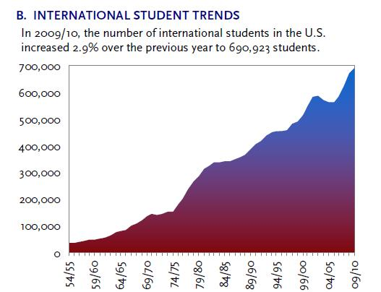
Figure 1. International Student Trends
As educational institutions increase their utilization of e-learning technology, certain considerations must be made concerning the broader audiences being exposed to these learning environments. Research shows that a range of differences exist in both learning and behavioral orientation amongst various cultures (Lim, 2004). Generally, a student’s learning and achievement is influenced by their national and ethnic orientation (Lim, 2004). Furthermore, these differences are even more apparent in situations that present activities both new and/or foreign to the learner. High uncertainty, stress and anxiety caused by these situations may cause the learner to resist full acceptance of any learning environment (Lim, 2004). Instructors need to consider the different perceptions of e-learning and etiquette's among varying cultures.
As multiculturalism and global thinking are becoming such important aspects of society and education (Hanson & Zambito, 2003), it becomes increasingly important for educational institutions to pay extra attention to the needs of international students regarding their orientation upon entering the United States. Internationalization is currently being addressed by George Mason University, as they clearly state in their Strategic Goals for 2014 (Strategic Planning Committee, 2008). GMU holds its diversity standards very highly, as the broad spectrum of demographics brings a range of perspectives that can both unite and divide. With that being said, GMU charges to maintain accessibility for students from various cultural backgrounds and highlighting the diversity of the student body in relationship with the ever changing composition of the larger population, while expanding the benefits of this diversity in the educational process and in graduate instruction (Strategic Planning Committee, 2008).

It is for these reasons that we decided to focus our efforts into creating an online learning module that provides a cultural orientation to international students at George Mason University. This online orientation will be developed to give international students a thorough idea about what to expect in terms of academic and transition expectations prior to their move to the US or once they reach the US territories and ways to overcome any challenges they face through interactive activities at GMU.
Our team believes that one way to reduce culture shock is by introducing students to the life in the U.S. by designing an online orientation. The online orientation is an online learning environment where Moodle will be used; Moodle is an online software that assists in creating an online course worldwide by universities, schools, companies and independent teachers (http://moodle.com/?moodlead=moodle.general). Moodle is an abbreviation for Modular Object-Oriented Dynamic Learning Environment, which has many helpful features that will engage international students in activities that will prepare them to overcome culture shock or at least reduce its impact on them.
Among the several features that Moodle provides, images and videos will be included in the online orientation to motivate students to understand and absorb the material provided to them. This way, students will get the chance to see some real life activities that take place in the United States in general and at GMU in particular. Using Moodle, there will be a focus on student’s interaction while delivering instruction on the life in the U.S. as well as engaging students to recognize how to cope with culture shock. Also, the quiz feature will be used for individual use where students will have the opportunity to test themselves on how much they are prepared and if they can certainly overcome the culture shock.
International students will be free to take the course prior to coming to the United States or once they get here, on condition that they are admitted to a program of study at George Mason University or are enrolled in English as a Second Language course at the English Language Institute at GMU. In sum the students should have a G number to be able to log in to the course. The course can be facilitated by staff at the Office of International Programs and Services (OIPS) at GMU. The course will be open for one month for the students to take. It usually opens one month prior to every semester and all international students may register to take it which allows collaboration between students from different countries.
Finally, with the usage of Moodle we hope to prepare the international students to overcome the culture shock that they may face when coming to the U.S. Overcoming the culture shock assists in allowing the international students in overcoming several challenges that may affect their academic achievement as well as may affect them emotionally.

References
Institute of International Education. (2010). Opendoors 2010 fast facts. Retrieved on March 23,
2011 from http://www.iie.org/en/Research-and-Publications/Open-Doors/Data.
Lim, Doo H. (2004). Cross Cultural Differences in Online Learning Motivation. Retrieved on March 22, 2011 from http://www.eric.ed.gov/ERICWebPortal/search/detailmini.jsp?_nfpb=true&_&ERICExtSearch_SearchValue_0=ED492446&ERICExtSearch_SearchType_0=no&accno=ED492446
Mallett, K.K & Zgheib, G. (In progress). Assessing a language-supported program for
international students at George Mason University: A mixed-method, longitudinal research
study of ACCESS students’ and faculty experiences.
Hanson, Lea R., & Zambito, Jill. (2003). The Troubling Issues Facing International Students Today. Retrieved on March 23, 2011 from http://www.colostate.edu/Depts/SAHE/JOURNAL2/2003/HansonZambito.htm
Strategic Planning Committee. (2008). Strategic Goals for 2014, George Mason University. http://provost.gmu.edu/documents/FINAL_Strategic_Goals_for_2014.pdf
Zhou, L. (2004). Foreign Students Face Challenges: Homesickness, language barrier confront
international students. Retrieved on March 23, 2011 from
http://www.thecrimson.com/article/2004/12/17/foreign-students-face-challenges-mihaela-
pacurar/#

